The connection to the permanently installed pipeline is in the south harbor next to the western footing of Sandholdt Bridge. This pipeline should be used during hydraulic dredging activities, and size is 10 inches inside diameter, and includes a mounting flange (see image below). The pipeline has been used for every dredge event for the past 20 years, and the last time the permanently installed pipeline was used was during the 2019 maintenance dredging event.

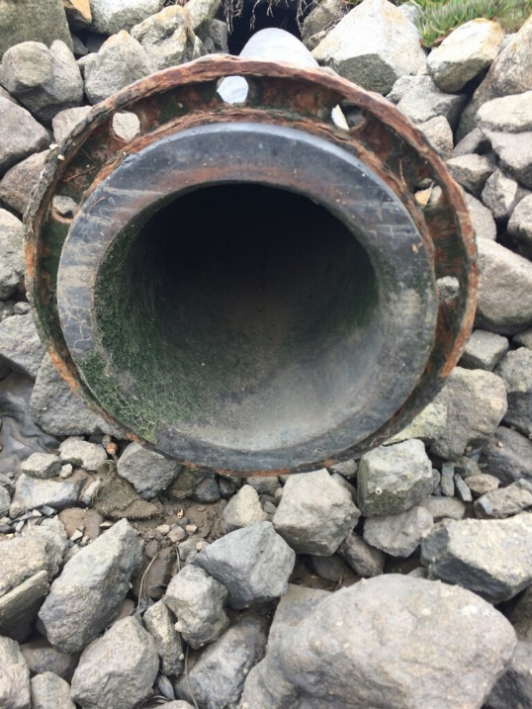

END OF ADDENDUM #2