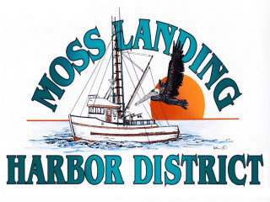
MLHD
REAL PROPERTY COMMITTEE
SPECIAL MEETING NOTICE
Wednesday January 12, 2022 at 1:30pm
Russ Jeffries, Chair
Tony Leonardini, Vice Chair

Moss Landing Harbor District is inviting you to a scheduled Zoom meeting.
Join Zoom Meeting
https://us02web.zoom.us/j/89919004196?pwd=QjdjNWE1YnRCaVJBaGRCTTRrVE5nQT09
Meeting ID: 899 1900 4196
Passcode: 798461
One tap mobile
+16699006833,,89919004196#,,,,*798461# US (San Jose)
+12532158782,,89919004196#,,,,*798461# US (Tacoma)
Meeting ID: 899 1900 4196
Passcode: 798461
Find your local number: https://us02web.zoom.us/u/kbuxhECDgn

A. Closed Session 1:30 P.M: The Committee will discuss the following matters:

1. Confer with real property negotiators (District Counsel and GM) pursuant to Government Code Section 54956.8 - Moss Landing Commercial Park proposal concerning Outfall Line, East Harbor Pumping Pier Property and Berthing Spaces.

2. Confer with real property negotiators (District Counsel and GM) pursuant to Government Code §54956.8 regarding: Development proposal received regarding the District New 9500’sf building in North Harbor.

3. Confer with real property negotiators regarding a lease and potential development of APN #133241003000 by Lusamerica Foods. Inc.

4. Confer with District Counsel pursuant to Government Code Section 54956.9 (a)(d)(4)- determination on recommendation to initiate litigation.

B. Open Session

1. Committee Remarks:

2. Public Comment:

C. Adjournment

