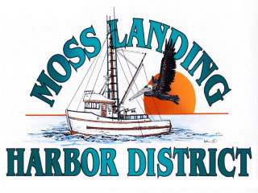
MLHD
REAL PROPERTY COMMITTEE
SPECIAL MEETING NOTICE
Monday April 18, 2022 at 1:00pm
Russ Jeffries, Chair
Tony Leonardini, Vice Chair

A. Public Comment regarding closed session items.

B. Closed Session 1:pm: The Committee will discuss the following matters:

1. Confer with real property negotiators and the District consultant (District Counsel and GM) pursuant to Government Code §54956.8 regarding: Development proposal received regarding the District’s new 9500’sf building in North Harbor.

B. Open Session2pm:

1. Discuss potential development and lease with possible tenant of the District’s New North Harbor Building.

2. Public Comment on matters within the Committee’s jurisdiction.

C. Adjournment

