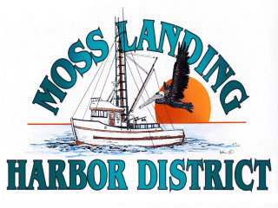
MLHD
REAL PROPERTY COMMITTEE
SPECIAL MEETING NOTICE
Wednesday February 15, 2023 at 1:30pm
Russ Jeffries, Chair
Vince Ferrante, Vice Chair
Tony Leonardini, Appointed Public Representative

- Public Comment regarding closed session matters.

B. Closed Session 1:30 P.M: The Committee will recess to closed session to discuss the following matters:

1. Confer with real property negotiators (District Counsel and GM) pursuant to Government Code Section 54956.8 - Moss Landing Commercial Park proposal concerning Outfall Line, East Harbor Pumping Pier Property and Berthing Spaces.

2. Confer with real property negotiators (District Counsel and GM) pursuant to Government Code §54956.8 regarding: Development proposal received regarding the District New 9500’sf building in North Harbor.

3. Closed session report and Committee Remarks

B. Adjournment:

