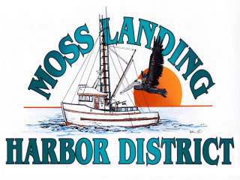
NOTICE OF CANCELED MLHD MEETINING OF THE BOARD

October 19, 2023

NOTICE OF CANCELED MEETING

The October 25, 2023, Regular Meeting of the Board of Harbor Commissioners has been canceled. The next meeting of the MLHD Board is scheduled to take place as a Special Meeting on December 13, 2023 beginning at 2:00 P.M.

If you have any questions, please contact the Harbor Administration Department at 831.633.5417

