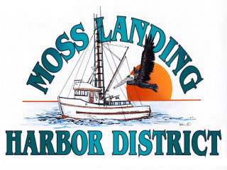
NOTICE OF CANCELED MLHD MEETINING OF THE BOARD

July 26, 2023

NOTICE OF CANCELED AND RESCHEDULED MEETING

The July 26, 2023 Regular Meeting of the Board of Harbor Commissioners has been canceled due to scheduling needs. A Special Meeting of the Board of Harbor Commissioners, at which the Board's regular and routine business will be conducted, has been scheduled to take place on August 3, 2023 beginning at 7pm.

If you have any questions please contact the Harbor office at 831.633.5417

