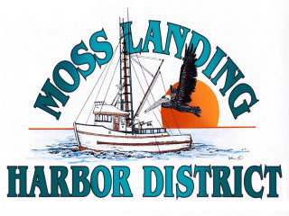
MLHD
REAL PROPERTY COMMITTEE
SPECIAL MEETING NOTICE
Wednesday April 21, 2021 at 2:30pm
Russ Jeffries, Chair
Tony Leonardini, Vice Chair

Moss Landing Harbor District is inviting you to a scheduled Zoom meeting.

Topic: Real Property Committee Meeting, Moss Landing Harbor District
Time: April 21, 2021 02:30 PM Pacific Time (US and Canada)

Join Zoom Meeting
https://us02web.zoom.us/j/89776369919?pwd=YlZBWDlQVVdHUGt3aXhEem5uM1lsQT09

Meeting ID: 897 7636 9919
Passcode: 660728
One tap mobile
+16699006833,,89776369919#,,,,*660728# US (San Jose)
+13462487799,,89776369919#,,,,*660728# US (Houston)

Dial by your location
+1 669 900 6833 US (San Jose)
+1 346 248 7799 US (Houston)
+1 253 215 8782 US (Tacoma)
+1 312 626 6799 US (Chicago)
+1 929 205 6099 US (New York)
+1 301 715 8592 US (Washington DC)
Meeting ID: 897 7636 9919
Passcode: 660728
Find your local number: https://us02web.zoom.us/u/kXmSzVL8I

A. Closed Session 2:30pm: The Committee will discuss the following matters:

1. Confer with real property negotiators (District Counsel and GM) pursuant to Government Code §54956.8 regarding: a. Development proposal received from Loop APN#413022002000 b. Lusamerica unimproved lot lease/reimbursement agreement and potential development APN# 133241003000; c. Moss Landing Marine Storage lease located adjacent to the Moss Landing Harbor offices located at 7881 Sandholdt Rd.

B. Open Session: 3:00pm or as soon as closed session has completed :

1. Discuss Board approved reimbursement agreement with Lusamerica Foods Inc. related to the potential development of APN #133241003000.

2. Discuss development proposal received from Loop regarding APN#413022002000 in the Moss Landing North Harbor.

B. Adjournment

