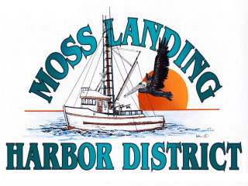

AD HOC
BUDGET COMMITTEE MEETING

Friday, March 25, 2022 at 10:00 am

MOSS LANDING HARBOR DISTRICT
CONFERENCE ROOM

AGENDA: Continue Discussion of Preliminary Budget for Fiscal Year 2022/23

