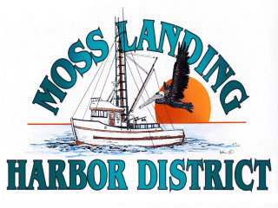
MLHD
REAL PROPERTY COMMITTEE
SPECIAL MEETING NOTICE
Wednesday October 27, 2021 at 3:00pm
Russ Jeffries, Chair
Tony Leonardini, Vice Chair

Moss Landing Harbor District is inviting you to a scheduled Real Property Committee meeting.

Join Zoom Meeting
https://us02web.zoom.us/j/81539495130?pwd=emUyUitDU1FvWDRqeEI2VEJERi9MUT09

Meeting ID: 815 3949 5130
Passcode: 382965
One tap mobile
+16699006833,,81539495130#,,,,*382965# US (San Jose)
+12532158782,,81539495130#,,,,*382965# US (Tacoma)
Meeting ID: 815 3949 5130
Passcode: 382965
Find your local number: https://us02web.zoom.us/u/kF6LAgltM

A. Closed Session 3pm: The Committee will discuss the following matters:

1. Confer with real property negotiators (District Counsel and GM) pursuant to Government Code §54956.8 regarding: Development proposal received regarding the District New 9500’sf building in North Harbor.

2. Confer with real property negotiators (District Counsel and GM) pursuant to Government Code Section 54956.8 - Moss Landing Commercial Park District proposal concerning Outfall Line, East Harbor Pumping Pier Property and Berthing Spaces.;

3. Meet and confer with legal counsel pursuant to Government Code 54956.9(d)(4) deciding whether to initiate litigation.

B. Adjournment

