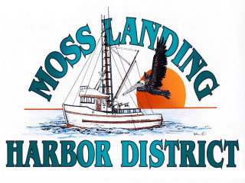
MLHD
REAL PROPERTY COMMITTEE
SPECIAL MEETING NOTICE
Wednesday May 4, 2022 at 1:00pm
Russ Jeffries, Chair
Tony Leonardini, Vice Chair

A. Public Comment regarding closed session items.

B. Closed Session: The Committee will discuss the following matters.

1. Confer with real property negotiators and the District consultant (District Counsel and GM) pursuant to Government Code §54956.8 regarding: Terms and conditions of development proposal received regarding the District’s new 9500’sf building in North Harbor.

2. Confer with real property negotiators, District Counsel and GM pursuant to Government Code §54956.8 regarding terms and conditions of a potential new lease for Reel Good Fish at the District’s Santa Cruz Cannery Building.

C. Adjournment

