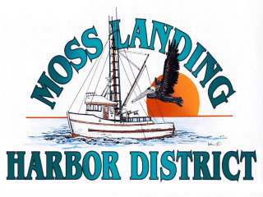
MLHD
REAL PROPERTY COMMITTEE
SPECIAL MEETING NOTICE
Wednesday March 3, 2021 at 2:00pm
Russ Jeffries, Chair
Tony Leonardini, Vice Chair

Moss Landing Harbor District is inviting you to a scheduled Zoom meeting.

Topic: Real Property Committee Meeting, Moss Landing Harbor District
Time: Mar 3, 2021 02:00 PM Pacific Time (US and Canada)

Join Zoom Meeting
https://us02web.zoom.us/j/87046832847?pwd=WjAxTG4xK2VhUFJGT2FCdS9tNlRhUT09

Meeting ID: 870 4683 2847
Passcode: 946255
One tap mobile
+16699006833,,87046832847#,,,,*946255# US (San Jose)
+13462487799,,87046832847#,,,,*946255# US (Houston)

Dial by your location
+1 669 900 6833 US (San Jose)
+1 346 248 7799 US (Houston)
+1 253 215 8782 US (Tacoma)
+1 301 715 8592 US (Washington DC)
+1 312 626 6799 US (Chicago)
+1 929 205 6099 US (New York)
Meeting ID: 870 4683 2847
Passcode: 946255
Find your local number: https://us02web.zoom.us/u/keqL8LO2FE

A. Closed Session 2pm: The Committee will discuss the following matters:

1. Confer with real property negotiators (District Counsel and GM) pursuant to Government Code §54956.8 regarding: a. Development proposal received from Loop APN#413022002000 b. Lusamerica unimproved lot lease and potential development APN# 133241003000; c. Moss Landing Marine Storage lease located adjacent to the Moss Landing Harbor offices located at 7881 Sandholdt Rd.

B. Open Session: 3:00pm or as soon as closed session has completed :

1. Discuss development proposal received from Loop regarding APN#413022002000 in the Moss Landing North Harbor.

B. Adjournment

