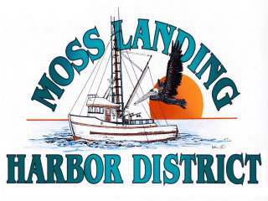
MINUTES
SPECIAL MEETING
OF THE BOARD OF HARBOR COMMISSIONERS
MOSS LANDING HARBOR DISTRICT
7881 Sandholdt Road, Moss Landing, CA 95039

August 13, 2019 - 6:00 P.M.

A. OPEN SESSION CALLED TO ORDER AT 6:08pm- PLEDGE OF ALLEGIANCE – ROLL CALL
Russ Jeffries – President Mike Rodriquez – District Counsel Tony Leonardini – Vice President Tommy Razzeca – General Manager
Vince Ferrante – Secretary
Peggy Shirrel – Commissioner
James Goulart – Commissioner
B. closed session public comment
No public comment.

C. Closed Session 6:09pm
The Board of Harbor Commissioners will recess to Closed Session to consider Government Code Section 54957(B)(1)- General Manager Evaluation.

D. Closed Session Report
Direction was provided by the Board to the General Manager. No other reportable action taken.

E. ADJOURNMENT
The meeting Adjourned at 8:40pm

