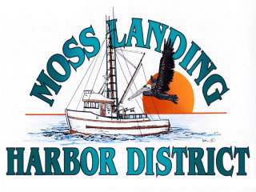
MLHD
REAL PROPERTY COMMITTEE
SPECIAL MEETING NOTICE
Wednesday December 15, 2021 at 10:15am
Russ Jeffries, Chair
Tony Leonardini, Vice Chair

Moss Landing Harbor District is inviting you to a scheduled Zoom meeting.

Join Zoom Meeting
https://us02web.zoom.us/j/82797536192?pwd=VVJjQ1ZuZTRZWlJNSVpLdDlrOWt3dz09

Meeting ID: 827 9753 6192
Passcode: 485250
One tap mobile
+16699006833,,82797536192#,,,,*485250# US (San Jose)
+12532158782,,82797536192#,,,,*485250# US (Tacoma)

A. Closed Session 10:15 A.M: The Committee will discuss the following matters:

1. Confer with real property negotiators (District Counsel and GM) pursuant to Government Code Section 54956.8 - Moss Landing Commercial Park District proposal concerning Outfall Line, East Harbor Pumping Pier Property and Berthing Spaces.

2. Confer with real property negotiators (District Counsel and GM) pursuant to Government Code §54956.8 regarding: Development proposal received regarding the District New 9500’sf building in North Harbor.

B. Open Session

1. Committee Remarks:

2. Public Comment:

C. Adjournment

