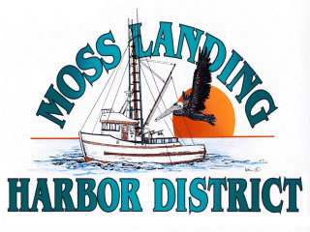

AD HOC
BUDGET COMMITTEE MEETING

Friday, March 22, 2024 at 10:00 am

MOSS LANDING HARBOR DISTRICT
CONFERENCE ROOM

AGENDA: Discuss Preliminary Budget for Fiscal Year 2024/25

