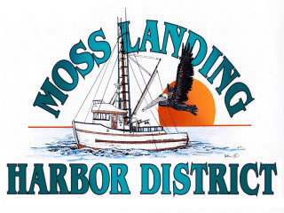
MLHD
REAL PROPERTY COMMITTEE
SPECIAL MEETING NOTICE
Wednesday January 13, 2021 at 3:00pm
Russ Jeffries, Chair
Tony Leonardini, Vice Chair

Moss Landing Harbor District is inviting you to a scheduled Zoom meeting.

Join Zoom Meeting
https://us02web.zoom.us/j/88255189097?pwd=Sk10RHFLL2l0T0xTam1lc2ZtWW5RUT09

Meeting ID: 882 5518 9097
Passcode: 402871
One tap mobile
+16699006833,,88255189097#,,,,*402871# US (San Jose)
+13462487799,,88255189097#,,,,*402871# US (Houston)

Dial by your location
+1 669 900 6833 US (San Jose)
+1 346 248 7799 US (Houston)
+1 253 215 8782 US (Tacoma)
+1 312 626 6799 US (Chicago)
+1 929 205 6099 US (New York)
+1 301 715 8592 US (Washington D.C)
Meeting ID: 882 5518 9097
Passcode: 402871
Find your local number: https://us02web.zoom.us/u/kbDsAmhj9H

A. Closed Session 3pm: The Committee will discuss the following matters:

1. Confer with real property negotiators (District Counsel and GM) pursuant to Government Code §54956.8 regarding: a. Deep Water Deals Cannery Building lease; b. Lusamerica Cannery Building Lease; c. Lusamerica unimproved lot lease ; d. Loop proposal.

B. Open Session: 4:30pm :

1. Review proposed Deep Water Desal Santa Cruz Cannery building office space lease

2. Review proposed Lusamerica Foods Inc. Santa Cruz Cannery building office space lease

3. Review proposed Lusamerica Foods Inc. lease of the unimproved lot adjacent to Santa Cruz Cannery Building.

4. Review proposal received regarding Loop development in the Moss Landing Harbor District North Harbor.

B. Adjournment

