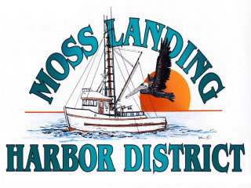
MLHD
REAL PROPERTY COMMITTEE
SPECIAL MEETING NOTICE
Wednesday November 18, 2020 at 12:15pm
Russ Jeffries, Chair
Tony Leonardini, Vice Chair

Moss Landing Harbor District is inviting you to a scheduled Zoom meeting of its Real Property Committee.

Join Zoom Meeting
https://us02web.zoom.us/j/82982971172?pwd=b1ZEYVEycUM0RG5KdXdyUERBNFRzZz09

Meeting ID: 829 8297 1172
Passcode: 736135
One tap mobile
+16699006833,,82982971172#,,,,,,0#,,736135# US (San Jose)
+12532158782,,82982971172#,,,,,,0#,,736135# US (Tacoma)

Dial by your location
+1 669 900 6833 US (San Jose)
+1 253 215 8782 US (Tacoma)
+1 346 248 7799 US (Houston)
+1 312 626 6799 US (Chicago)
+1 929 205 6099 US (New York)
+1 301 715 8592 US (Washington D.C)
Meeting ID: 829 8297 1172
Passcode: 736135
Find your local number: https://us02web.zoom.us/u/kdB2zYNlA5

I. Open Session The Committee will discuss the following matter:

1. Discuss lease proposal submitted by Lusamerica Foods Inc. regarding a potential lease of the storage yard located adjacent to the Cannery Building 7532 Sandholdt Road.

Only direction is to be provided on these matters and no reportable action is anticipated

