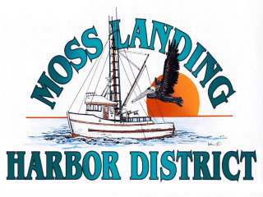
MLHD
REAL PROPERTY COMMITTEE
SPECIAL MEETING NOTICE
Wednesday March 30, 2022 at 3:00pm
Russ Jeffries, Chair
Tony Leonardini, Vice Chair

A. Public Comment regarding closed session items.

B. Closed Session: The Committee will discuss the following matters:

1. Confer with real property negotiators (District Counsel and GM) pursuant to Government Code §54956.8 regarding: Development proposal received regarding the District’s new 9500’sf building in North Harbor.

2. Confer with real property negotiators regarding a potential long term lease of shop and office space at the District’s Santa Cruz Cannery Building located at 7532 Sandholdt Road in Moss Landing.

B. Open Session

1. Closed Session report.

2. Committee Remarks.

3. Public Comment.

C. Adjournment

