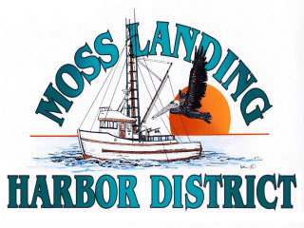
MLHD
REAL PROPERTY COMMITTEE
SPECIAL MEETING NOTICE
Wednesday November 17, 2021 at 1:00pm
Russ Jeffries, Chair
Tony Leonardini, Vice Chair

Moss Landing Harbor District is inviting you to a scheduled Real Property Committee meeting.
Join Zoom Meeting
https://us02web.zoom.us/j/84566815171?pwd=Q3M0c2dCaWRqeXpqVVBraVpmR0l3dz09

Meeting ID: 845 6681 5171
Passcode: 947586
One tap mobile
+16699006833,,84566815171#,,,,*947586# US (San Jose)
+13462487799,,84566815171#,,,,*947586# US (Houston)

Dial by your location
+1 669 900 6833 US (San Jose)
Meeting ID: 845 6681 5171
Passcode: 947586
Find your local number: https://us02web.zoom.us/u/kcOeYTbj0r

A. Closed Session 1pm: The Committee will discuss the following matters:

1. Discuss a potential lease to develop APN #133241003000 by Lusamerica Foods Inc.

B. Open Session: 1:45pm:

1. Representatives from Lusamerica Foods Inc. will address the committee regarding planned operations in Moss Landing Harbor and provide suggested property based concessions they believe the District should adopt to help support the local Commercial Fishing Industry.

C. Adjournment

