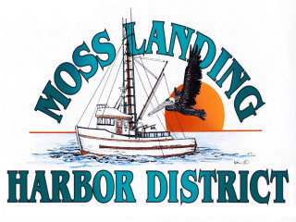
CANCELATION AND RESCHEDULING NOTICE FOR THE
MLHD MEETINING OF THE BOARD MARCH 2022

NOTICE OF CANCELED MEETING

The March 24, 2022 Regular Meeting of the Board of Harbor Commissioners is canceled. The meeting will be rescheduled to take place as a Special Meeting of the Board on
March 30, 2022.

