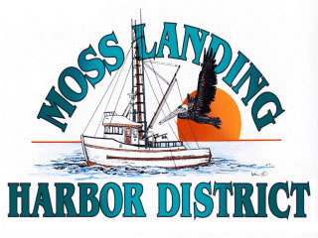
MLHD
REAL PROPERTY COMMITTEE
SPECIAL MEETING NOTICE
Wednesday May 25, 2022 at 5:00pm
Russ Jeffries, Chair
Tony Leonardini, Vice Chair

A. Public Comment regarding closed session items.

B. Closed Session 5:pm: The Committee will discuss the following matters:

1. Confer with real property negotiators (District Counsel and GM) pursuant to Government Code §54956.8 regarding: Development proposal received regarding the District’s new 9500’sf building in North Harbor.

C. Adjournment

