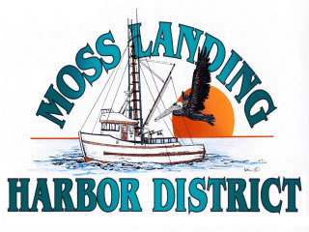

AD HOC
BUDGET COMMITTEE MEETING
Wednesday, March 10, 2021 at 12:30 pm

Moss Landing Harbor District is inviting you to a scheduled Zoom meeting.

Join Zoom Meeting
https://us02web.zoom.us/j/89967451670?pwd=YmoxM1I5dTBKeVJYdjB6QzBjZHA2Zz09

Meeting ID: 899 6745 1670
Passcode: 538594
One tap mobile
+16699006833,,89967451670#,,,,*538594# US (San Jose)
+12532158782,,89967451670#,,,,*538594# US (Tacoma)

Meeting ID: 899 6745 1670
Passcode: 538594
Find your local number: https://us02web.zoom.us/u/kbuqMnDJXk

AGENDA: Discuss Preliminary Budget for Fiscal Year 2021/22

