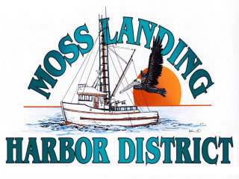
MLHD
REAL PROPERTY COMMITTEE
SPECIAL MEETING NOTICE
Tuesday December 16, 2025
Russ Jeffries, Chair
Vince Ferrante, Vice Chair
Tony Leonardini, Public Representative

.

A. Open Session 1:00 P.M.

- Public Comment

- Real property negotiators will meet and confer with representatives from Monterey County regarding the Moss Landing Community Plan update.

D. Adjournment:

