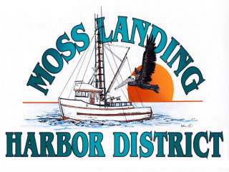
MLHD
REAL PROPERTY COMMITTEE
SPECIAL MEETING NOTICE
Tuesday March 8, 2022 at 1:00pm
Russ Jeffries, Chair
Tony Leonardini, Vice Chair

Open Session 1pm

1. North Harbor Building:

A. Public Comment
(Members of the public may provide public comment only on any item on the agenda.)

B. Meet with Staff and Consultants concerning building improvements.

C. Meet with prospective tenant concerning building improvements and lease terms.

*The Real Property Committee is an advisory body to the Board of Harbor Commissioners and no final action on behalf of the District will be taken on any of the matters listed on this agenda.

D. Adjournment

