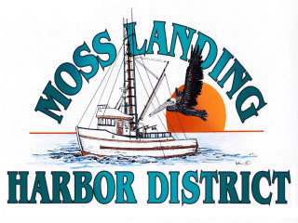
MLHD
REAL PROPERTY COMMITTEE
SPECIAL MEETING NOTICE
Thursday March 11, 2021 at 2:30pm
Russ Jeffries, Chair
Tony Leonardini, Vice Chair

Moss Landing Harbor District is inviting you to a scheduled Zoom meeting.

Join Zoom Meeting
https://us02web.zoom.us/j/82046458345?pwd=YkNVeHRTWjE0ZlBCKzRNRklqRlJ0Zz09

Meeting ID: 820 4645 8345
Passcode: 521168
One tap mobile
+16699006833,,82046458345#,,,,*521168# US (San Jose)
+13462487799,,82046458345#,,,,*521168# US (Houston)

Dial by your location
+1 669 900 6833 US (San Jose)
+1 346 248 7799 US (Houston)
+1 253 215 8782 US (Tacoma)
+1 929 205 6099 US (New York)
+1 301 715 8592 US (Washington DC)
+1 312 626 6799 US (Chicago)
Meeting ID: 820 4645 8345
Passcode: 521168
Find your local number: https://us02web.zoom.us/u/kY0z0ZgtA

A. Closed Session 2:30pm: The Committee will discuss the following matters:

1. Confer with real property negotiators (District Counsel and GM) pursuant to Government Code §54956.8 regarding: a. Development proposal/lease received from Loop APN#413022002000 b. Lusamerica unimproved lot lease APN# 133241003000; c. Moss Landing Marine Storage lease located adjacent to the Moss Landing Harbor offices located at 7881 Sandholdt Rd. d. Monterey Bay Kayak lease options APN#413022002000 in the Moss Landing North Harbor.

B. Open Session: 3:15pm or as soon as closed session has completed :

1. Discuss lease options of Monterey Bay Kayak related to changed conditions on APN#413022002000 in the Moss Landing North Harbor.

B. Adjournment

